**FINAL ASSESSMENT**

**Flight Booking**

By

Ayush Solanki

**AUTH MODULE**

Login

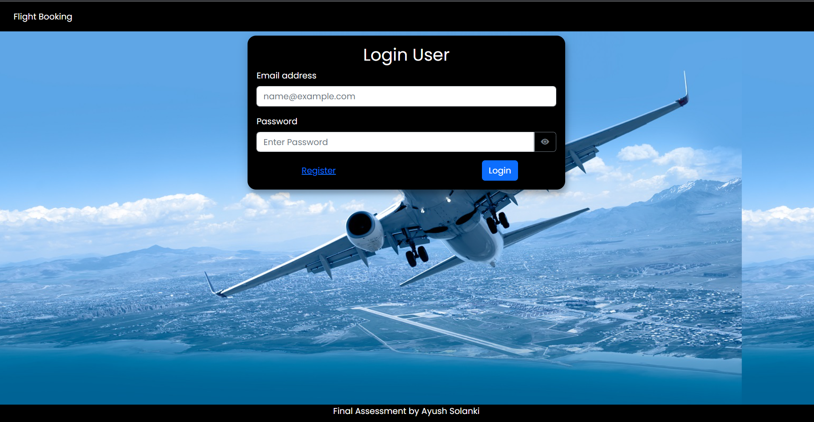

Register

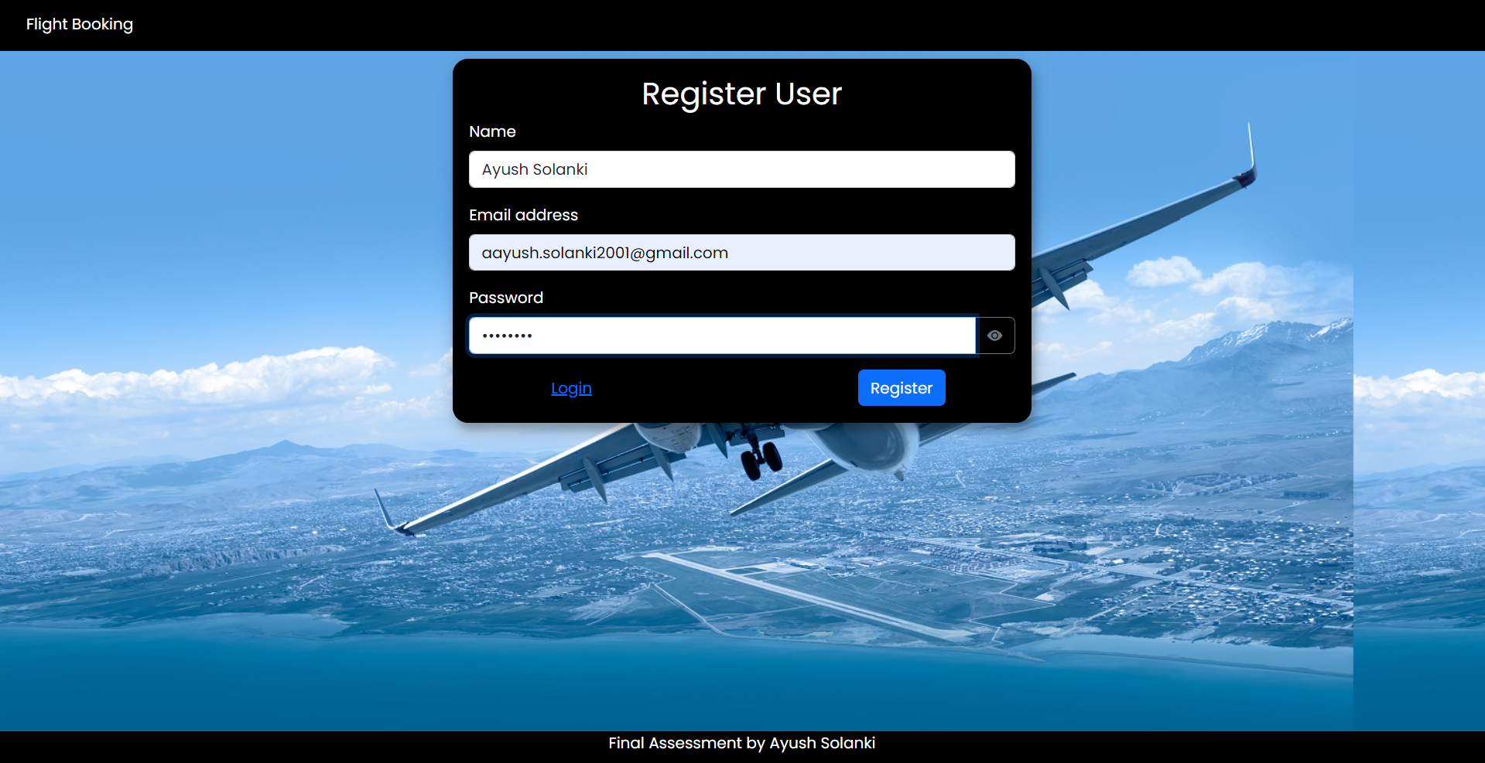

Confirm User

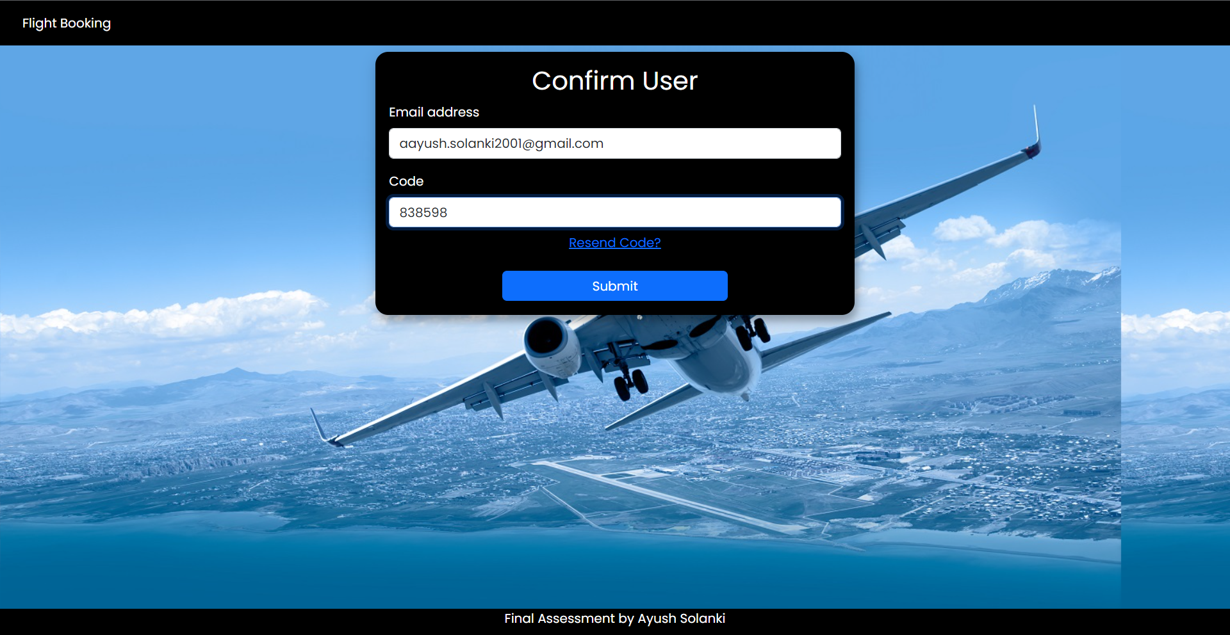

**HOME MODULE**

Home Page – Guideline for booking tickets

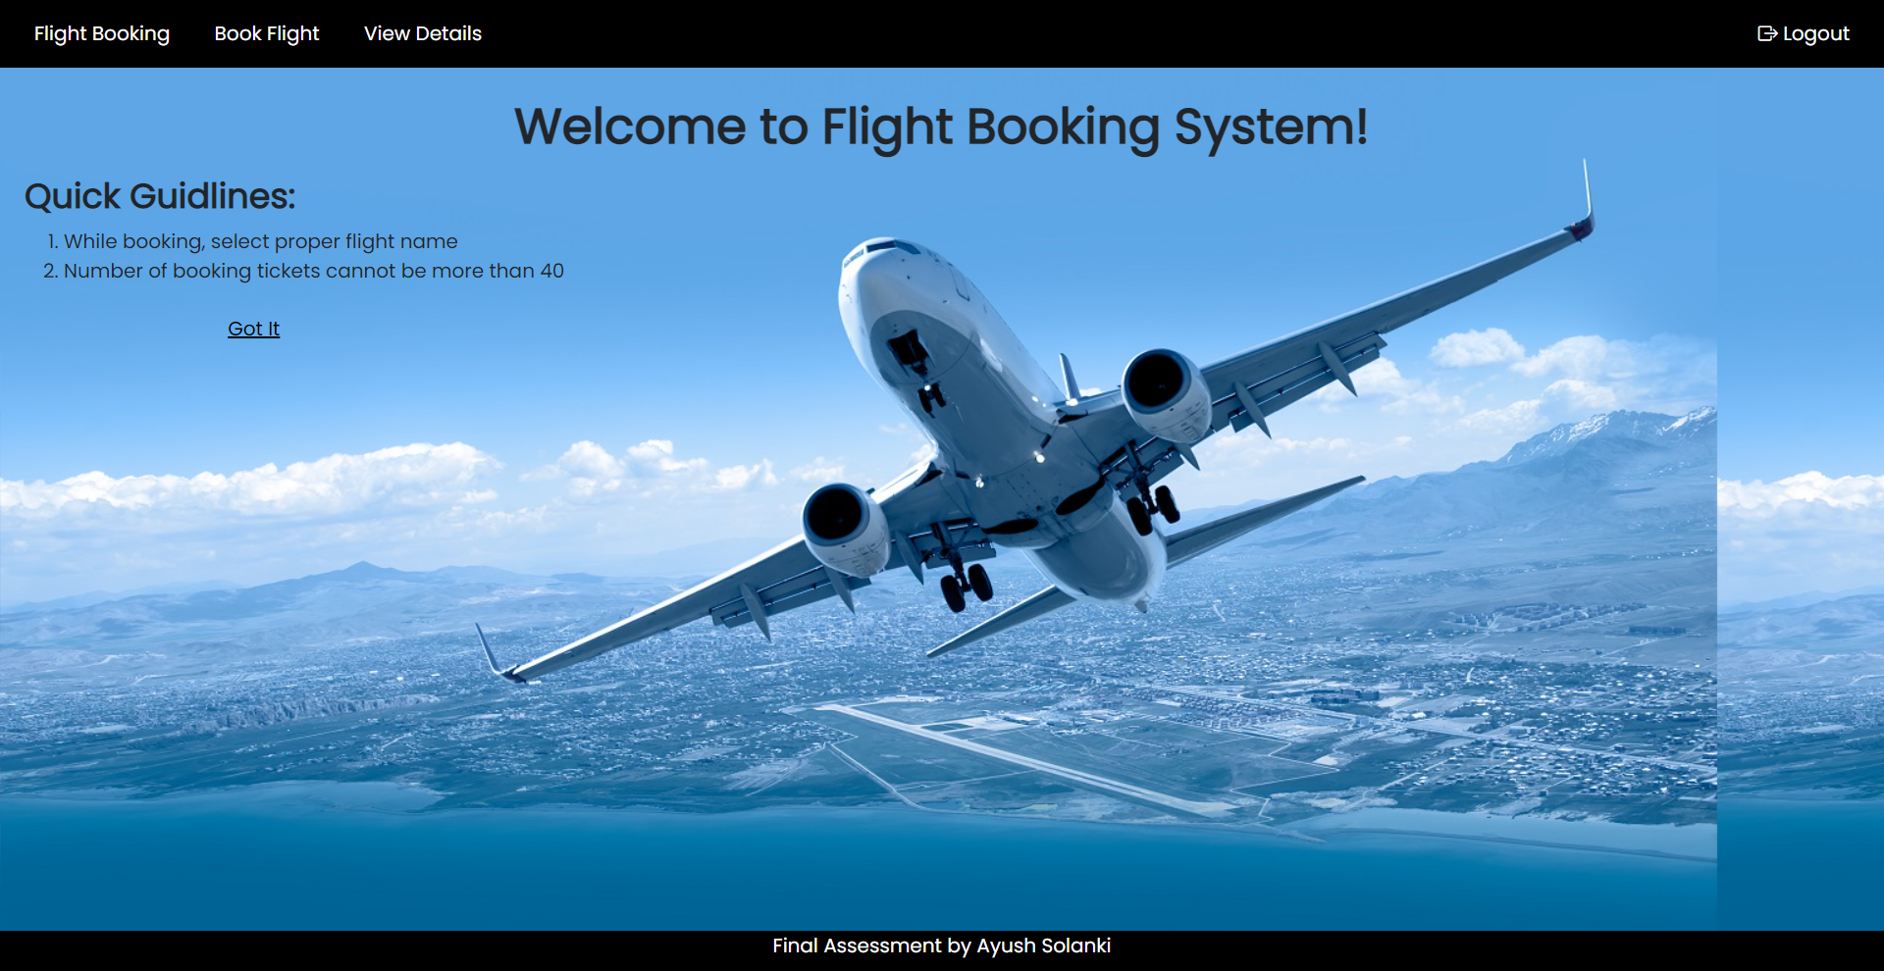

**BOOK TICKET MODULE**

Flight List

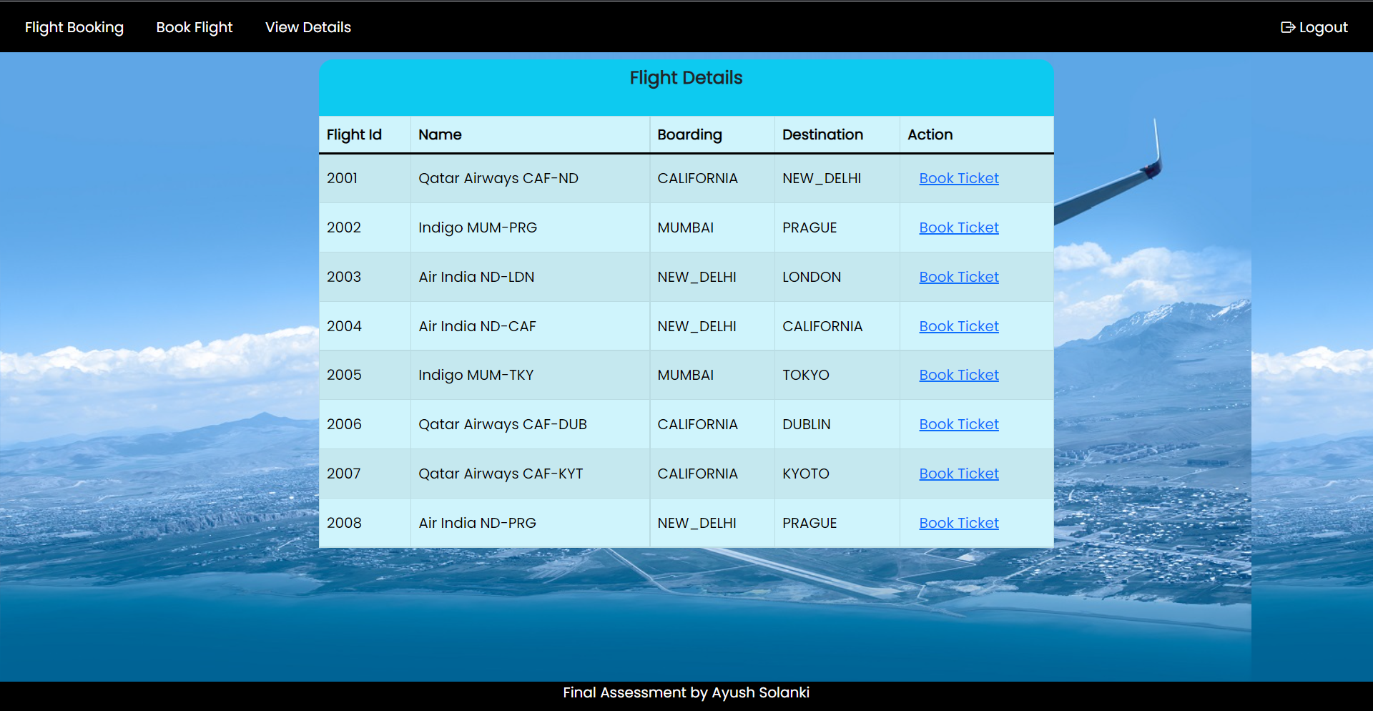

Book Ticket Form

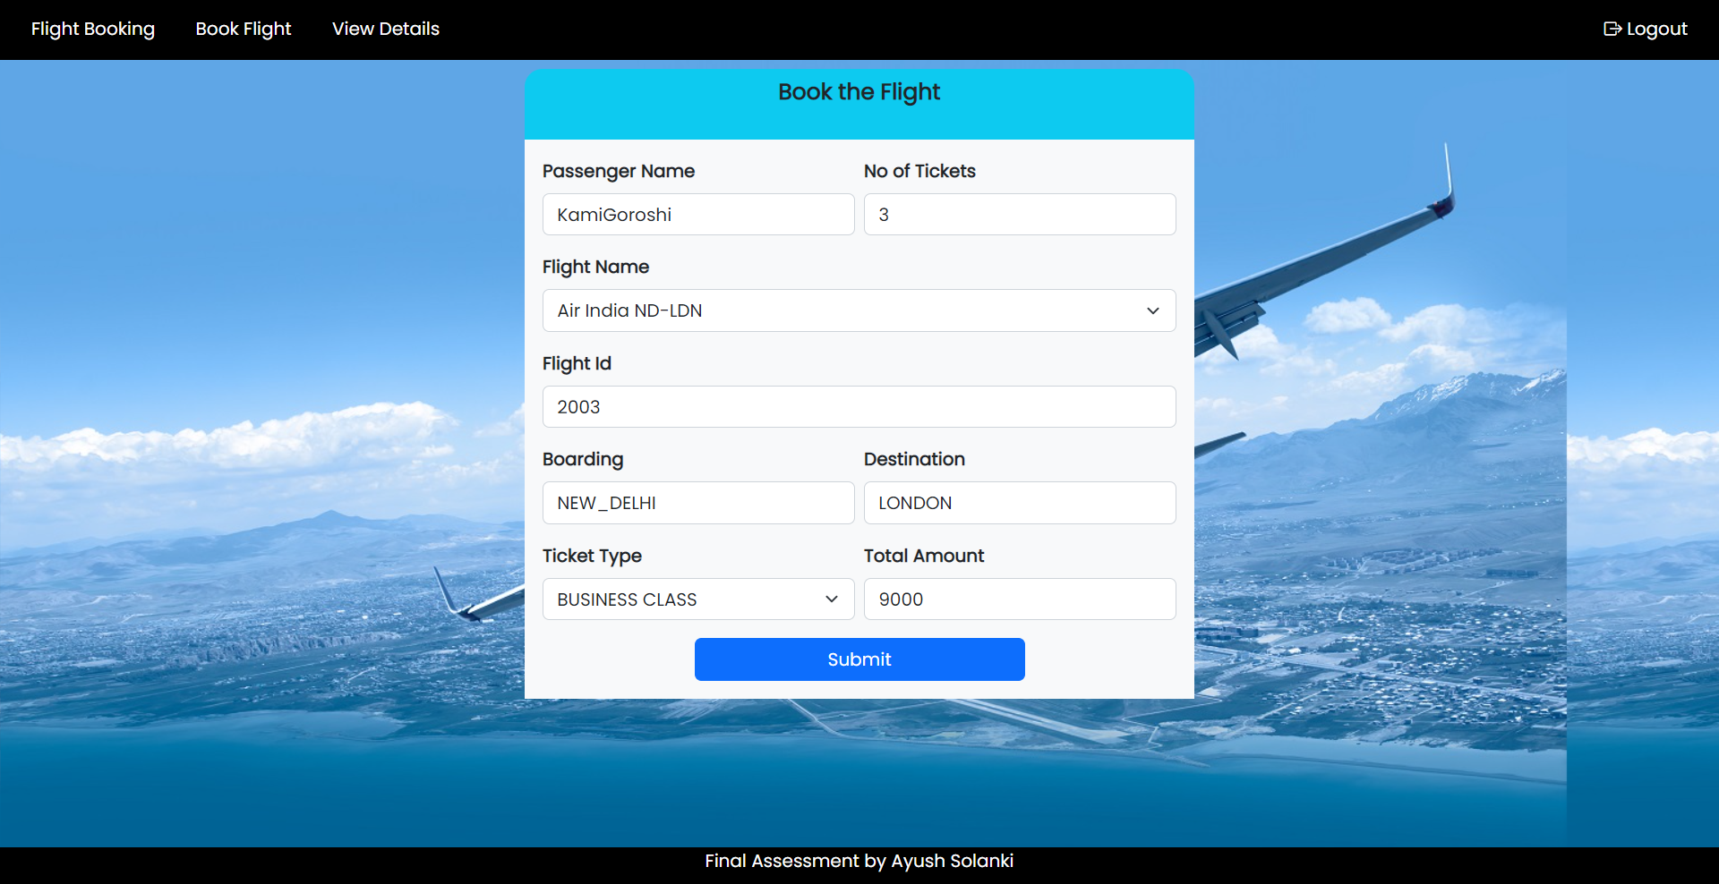

**VIEW DETAILS MODULE**

Bookings List

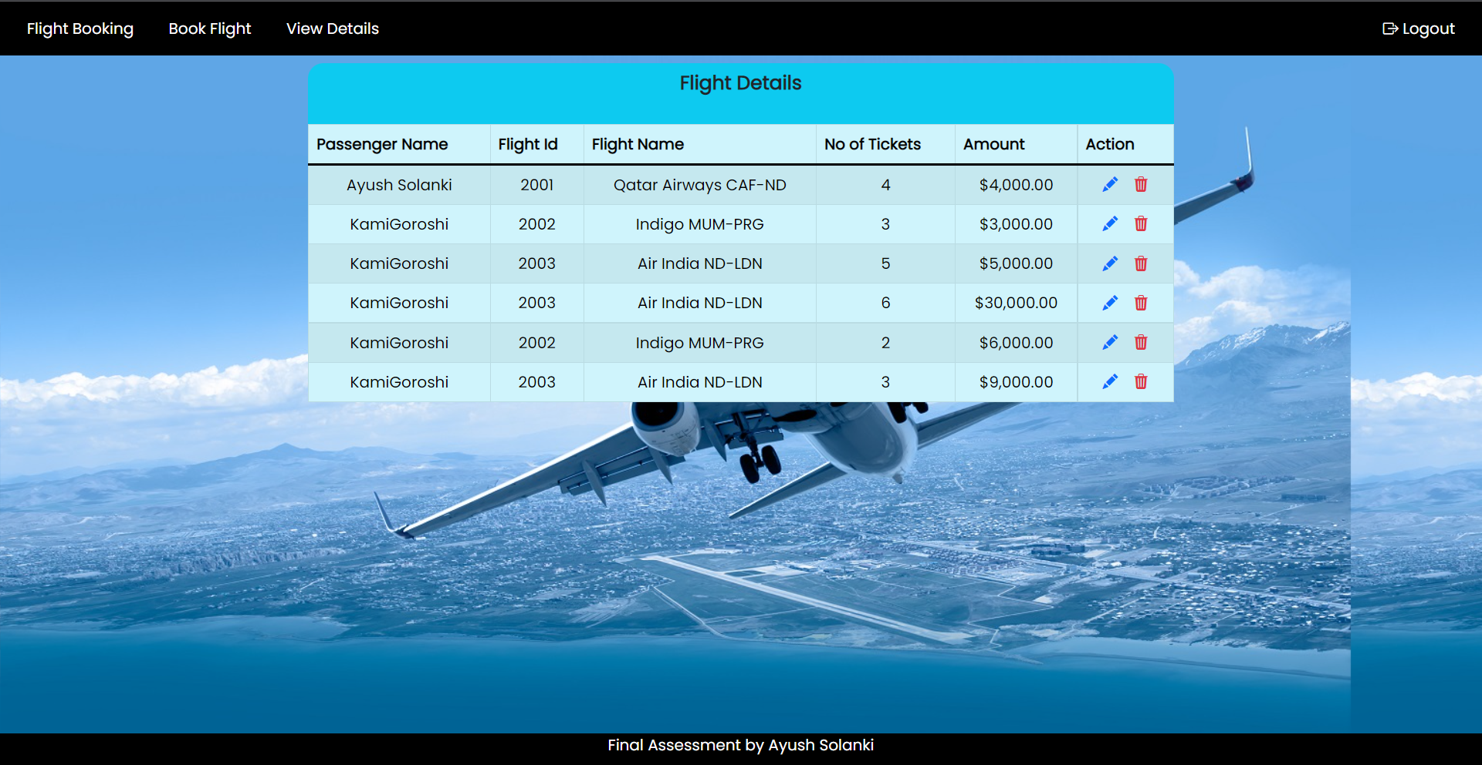

Update Booking

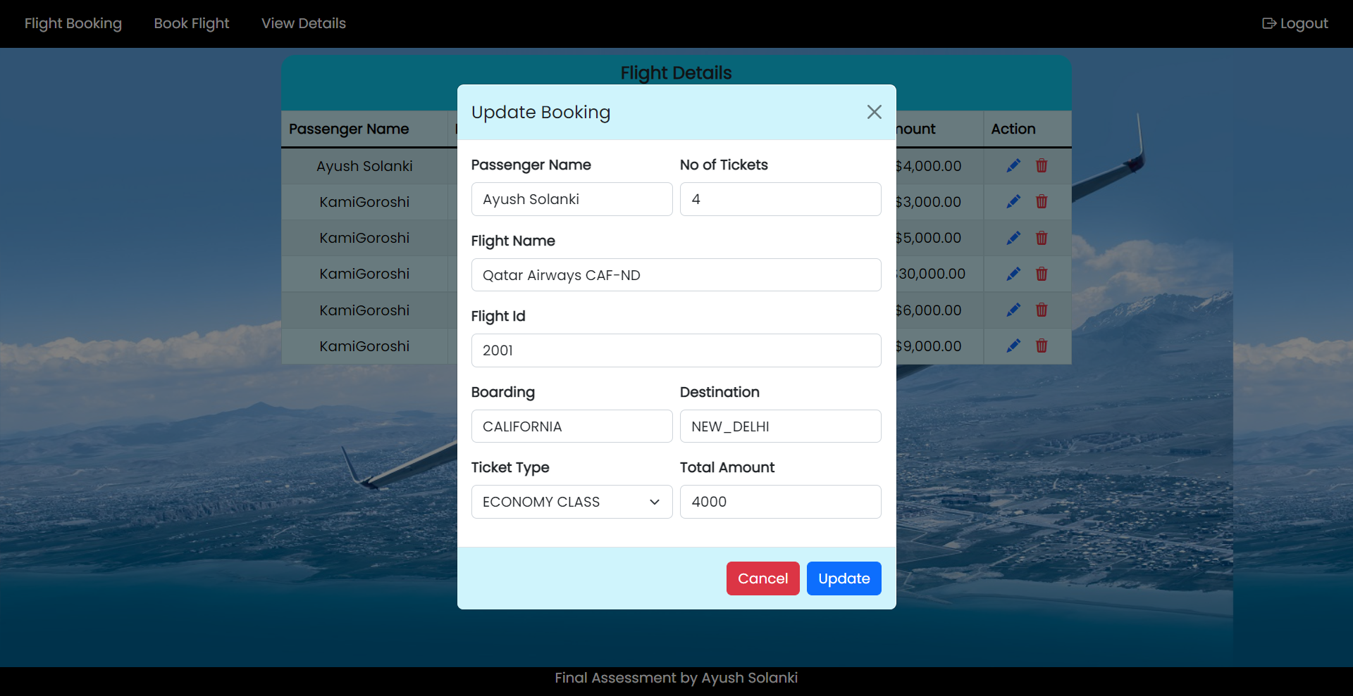

Delete Booking

